Content for Program Structure section

The overall structure of the code is illustrated schematically in Figure 1. This is implemented through several classes that handle the graphical user interface and program workflows (Main UI) and several classes that handle the data manipulation and plotting (Input UIs and Data UIs).

Figure - – High level schematic of program structure

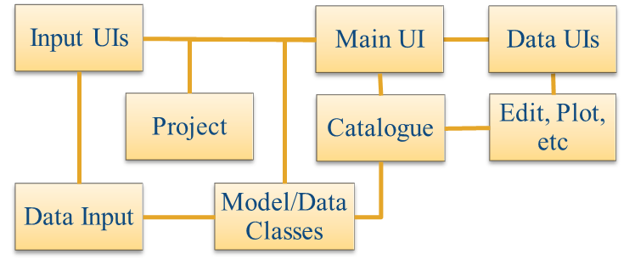

The interfaces and default functionality are implemented in the XXX App using the following muitoolbox classes depicted in Figure 2, which shows a more detailed schematic of the program structure. See the muitoolbox and dstoolbox documentation for more details.

Figure – schematic of program structure showing how the main classes from muitoolbox and dstoolbox are used

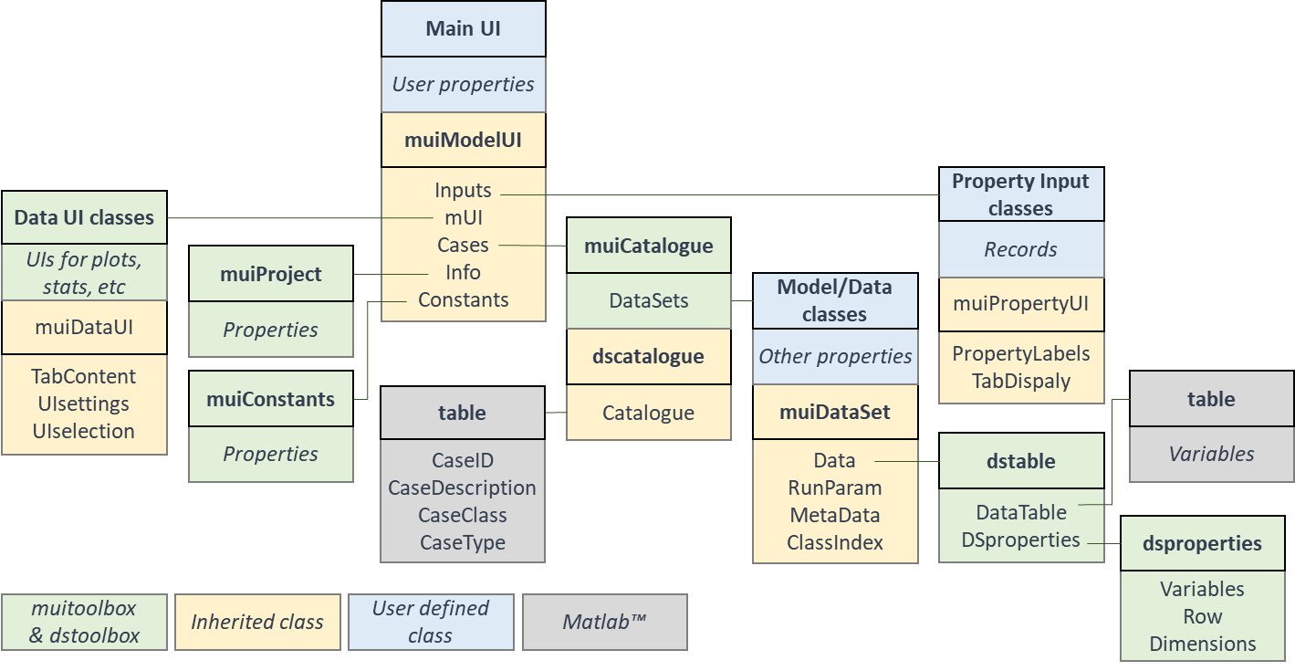

In addition, the XXX App uses the following classes and functions: